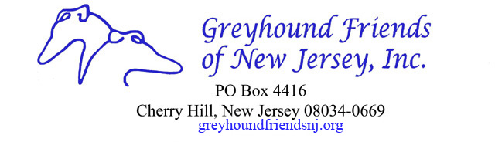
GFNJ/LITTLE HOUSE CANDLE FUNDRAISER ORDER FORM
NAME:
ADDRESS:
CITY/STATE/ZIP:
PHONE: E-MAIL:

SCENT | QUANTITY

PAYMENTS

Checks: payable to GFNJ

Mail: the Order Form to Greyhound Friends of NJ, PO Box 4416, Cherry Hill, NJ 08034
PayPal: go to the GFNJ website for info (www.gfnj.org)
E-Mail: the Order Form to lelyman7@verizon.net

$
Candles @ $15.oo =

