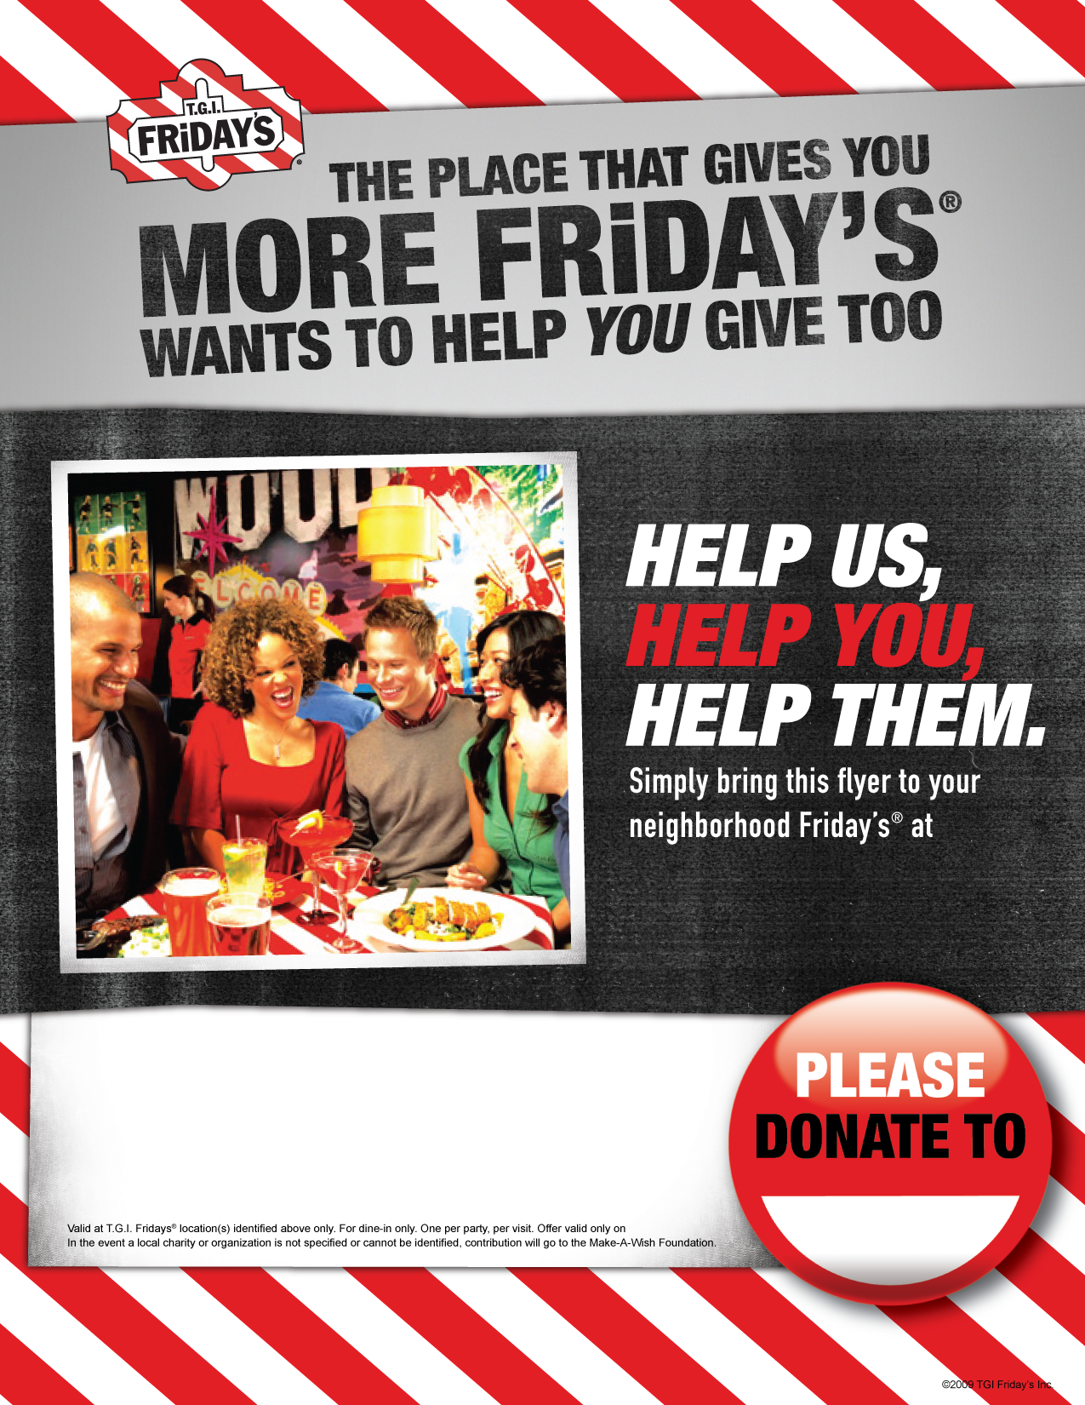
15% OF FOOD SALES WILL BE DONATED BETWEEN 5PM and 10PM WEDNESDAY, JANUARY 27, 2009
^{TGI FRIDAY’S PARSIPPANY, NJ}
3835 Route 46 East
Parsippany, NJ 07054
Greyhound Friends of New Jersey

