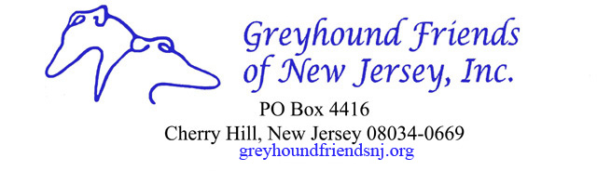
GFNJ Meet and Greet Cash Receipt
Location________________________________________________
Date of Event ______________________________
Coordinator________________________________ _
Cash donations received $_______________________
Checks received $______________________
Total donations received $___________________
Signed______________________Date_______________
Signed______________________Date_______________

Please return this form with your monthly checks to
Greyhound Friends of NJ, Inc.
P.O. Box 4416
Cherry Hill, NJ 08034
Please do not hold money for months at a time. Also, please sign the form and have another volunteer sign. If you have any questions, please call Linda at 856-751-5134.
You're asked to follow this "best practice" procedure based on the advice of our accountant.
Thank you so much.
Linda

