A Walk On The (Not So) Wild Side
by Heidi Gehret
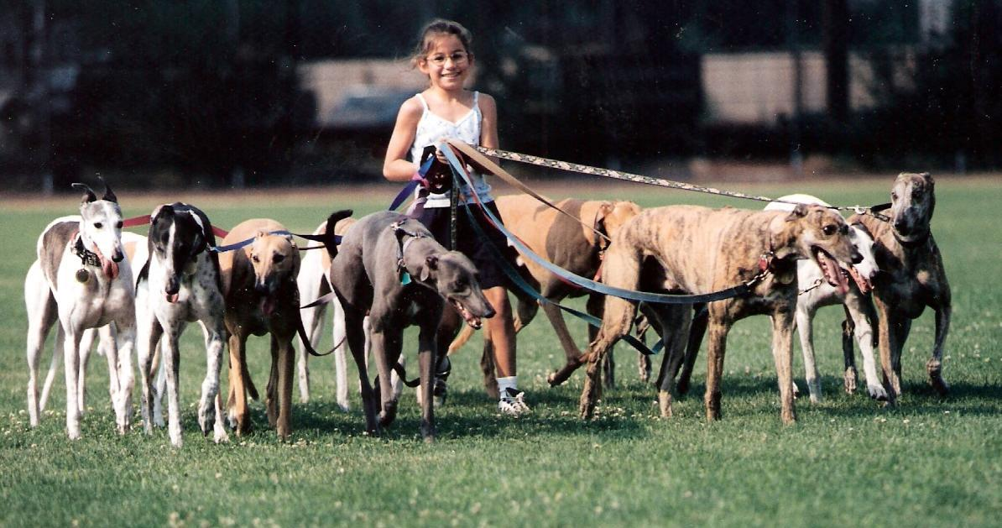
Walking your new greyhound is very important; you will get to know and trust each other, bond and become pals. It should be a happy, secure, calm experience, a time when your dog should know you’re in charge. A walk should also be a mental exercise when your dog learns that’s when she should “do her business” – it is not a social event, and pulling is out of the question.
Generally, greyhounds are good on a leash, since they were leash-walked at the track. They were always told by their handler where they were going by his body language and the way he held the leash. The dogs were rarely given a long lead and allowed to walk in front of the handler. They knew he was in charge. But many adopters fall into bad habits that allow their dog to get away with being the leader. That’s a “no-no.”
I’ve heard new greyhound owners say, “My dog pulls too much and tries to sniff all the other dogs we see. She swerves in front of me from side to side. Sometimes, we come back in and she pees in the house even though she just had a walk. Help!”
If your greyhound is showing any kind of behavior problem, the first place to start in solving it is the walk. Whether your dog is showing signs of separation anxiety, insecurities, housebreaking issues or anxious behaviors, the solution starts with a proper walk. Most behavior problems begin with a dog that is insecure, living with an owner who doesn’t know how to communicate that they are the one in control. Your body language will show your grey that you are in control and will help your dog feel less anxious when you approach a walk as a training outing, not a social outing.
Here’s a list of simple things to remember for new grey owners or owners having problems at home to make your walk together fun and satisfying from the beginning:
- Follow the leader: YOU are the leader and Lulu will see that from your body language. Before you leave the house, don’t make a big deal out of going for a walk. Don’t say, “Come on Lulu, let’s go out!!!” Instead, put the leash on and go calmly out the door. You’re in charge, so act like it. If your dog bounces around and jumps up on you, stand calmly and wait for her to stop. Be calm. Once she quiets down, snap the leash on her, if she starts to jump around, start the exercise over by waiting for her to calm down. No words needed, just stand and wait. She’ll learn that in order to go out for her walk she has to be calm. Hold the leash in one hand, looped securely wrapped around your wrist, and a firm grip on the other end closest to the dog’s collar with your other hand, giving the dog a sense that you’re in control. This gives you the opportunity to prevent Lulu from walking from side to side or ahead of you by holding her in line next to you, not ahead of you. Walk with your head up, confidently, your greyhound will feel secure and ready for your direction. If Lulu pulls, correct her by giving the leash a tug to the side, which throws her balance off a little and breaks his pulling motion. Don’t pull back – that just makes her want to pull more. When she responds to the correction, let the leash loose… that’s her reward. Remember, your greyhound knows how to do all this having been taught by the handlers at the track, now you need to make her realize you’re the boss. If you don’t, she’ll take on that role.
- Taking care of business: One of the best ways to housebreak your greyhound is to pick a place where they should do their business. At first, always walk to the same spot and say, “Go pee.” It won’t take long before she’ll go toward that spot as soon as you say the words, and you’ll be sure she’s ready to come back inside with no mistakes.
- No time to play: If you want Lulu to understand you’re the boss and she has to do what you want, do not let her stop to play, sniff or be sniffed by a passing dog. Not only could you be asking for trouble if the passerby isn’t as nice as his mommy says he is, but it disturbs your grey’s concentration. If you see a person approaching with their dog on a leash, try to avoid contact by crossing the street or saying, “Please keep your dog away, we’re in training.” Nothing offensive there.
- Leader of the pack: Greyhounds are pack animals. During a walk in a pack, they naturally find their spot which gives them a sense of security so they can let go and just be what they want to be…a greyhound and not a leader. That’s why it is so important to walk properly so your dog doesn’t feel she has to take over the leading position. Your family is now Lulu’s pack.
- Safety on walks: Unfortunately, greyhounds can sometimes be the targets of more aggressive dogs. The best idea is to be prepared. Although some say to take pepper spray or a stick with you on a walk, the best idea is to carry a badminton racket because you’ll have more control. It’s light-weight with a long handle and wide face. If an aggressive dog approaches you and your grey, push the offending dog away with the racket. Try to stay calm and don’t yell, which can make things worse. Walk confidently, stand tall, breathe and raise your racket in front of you. You will look authoritative to the aggressive dog and hopefully he will not target you and your greyhound. But if he does, you will have a tool to help block him. Be aware of other owners with their dogs. Is their dog pulling at the end of the lead, dragging his owner down the street? Does the dog’s body language seem to be very forward and focused on getting to your Lulu? Well, that’s a sure sign of that dog being leader of his pack. As the leader, I would never allow a dog acting in such a way to approach my pack.
We know they’re couch potatoes, but greyhounds need to get exercise to expend energy, which otherwise can result in a tense, destructive pet. There’s nothing like a good walk to keep you and your greyhound happy. Following these steps will help make it an easy exercise, so to speak.

