BLEEDING AND CLOTTING ISSUES IN GREYHOUNDS: DOS AND DON’TS
C. Guillermo Couto, DVM, dipl. ACVIM Couto Veterinary Consultants Hilliard, OH 43026 coutovetconsultants@gmail.com
With the increasing popularity of retired rescued Greyhounds, veterinarians are likely to evaluate dogs of this breed more frequently in their practice. Therefore, it is important that they recognize the physiological peculiarities of this breed. Spontaneous or delayed postoperative bleeding is one of them.
In the Greyhound community, the term “Greyhound bleeder” is typically used for dogs that bleed either spontaneously or 1-2 days after minor trauma or a simple surgical procedure. We have seen severe bleeding after routine major or minor surgical procedures, lacerations, tooth extractions, biopsies, blood draws, and even microchip placement.
We worked on hemostasis (clotting) in Greyhounds for over a decade, and determined that approximately 25% of retired racers will bleed 36-48 hours after a spay or neuter procedure; despite this, all the tests of hemostasis (clotting) are normal, and they do not differ between bleeders and non-bleeders. We have also seen this syndrome in Deerhounds, Italian Greyhounds, and other selected sighthound breeds.
The bleeding typically starts around the surgical site, and becomes extensive and disseminated. When confronted with a dog with disseminated bleeding, most veterinarians tend to diagnose them as disseminated intravascular coagulation (DIC) a serious, and oftentimes fatal syndrome of simultaneous clotting and bleeding. We have conclusively excluded DIC as a mechanism of bleeding in sighthounds.
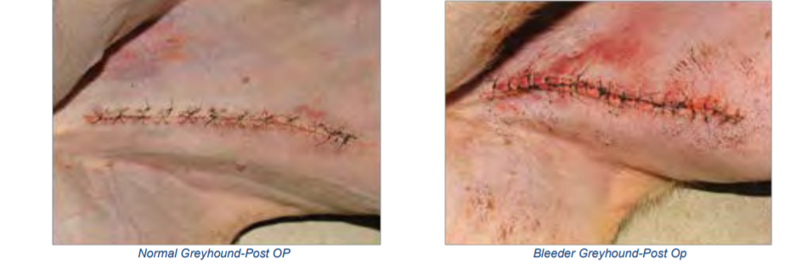
In normal dogs, the strength of a clot increases 24-48 hours after trauma of surgery, since effective clotting is the first step in healing (scarring). Our studies revealed that Greyhound “bleeders” are not able to increase the clot strength after surgery, as the “nonbleeders” and other non-Greyhound dogs do.
We extensively evaluated a pro-coagulant (epsilon aminocaproic acid-EACA or Amicar®), at dosages of 500- 1,000 mg, orally or intravenously, every 8 hours, for 5 days, starting the day of or the day after the surgery.
Thus drug significantly decreases the severity and frequency of bleeding in Greyhounds undergoing limb amputation for bone cancer, after spays/neuters, and other surgeries. It is also effective in dogs who bleed due to lacerations, dental extractions, etc. If EACA is not available, tranexamic acid (650-1,000 mg, PO, q8h) can be used.
PREVENTION OR TREATMENT OF SPONTANEOUS BLEEDING IN GREYHOUNDS: Aminocaproic acid or tranexamic acid, 500-1,000 mg, orally, 3 times a day for 5 days, starting the day of the surgery or the bleeding.
We also worked on the issue of thrombosis (clot formation) and thromboembolism (clot formation and migration) in Greyhounds. We recognized aortic, iliac, or femoral thrombosis as a cause of intermittent rear leg lameness in Greyhounds, and also identified the fact that retired racers are at high risk for brain or spinal cord thromboembolic events. The latter are acute, and cause severe neurologic signs (incoordination, paralysis, inability to move, excessive salivation, abnormal eye movement, etc). Mini-dose aspirin (1/4-1/2 cardio aspirin once a day) results in rapid, marked clinical improvement in these patients. We evaluated another drugs (Plavix), but in our hands it was not very effective in Greyhounds (however, it works well in non-Greyhound breeds and in cats).
PREVENTION OR TREATMENT OF SPONTANEOUS THROMBOSIS (CLOTS) IN GREYHOUNDS: Aspirin ½ to 1-81 mg tablets, orally, once a day.
REFERENCES
Lara García A, Couto CG, Iazbik MC, Brooks M: Postoperative bleeding in retired racing Greyhounds. J Vet Intern Med 2008; 22:525- 533. Lord L, Yaissle J, Marin L, Couto CG: Results of a web-based health survey in retired racing Greyhounds. J Vet Intern Med 2007;21:1243-1250. Marín LM, Couto CG, Iazbik MC, Westendorf N, Vilar Saavedra P: Effects of time of collection and sample processing on von Willebrand factor concentration in Greyhounds. J Vet Intern Med 2008; 22:1447-1448. Marin LM, Iazbik MC, Zaldivar-Lopez S, Guillamin J, McLoughlin MA, Couto CG. Epsilon Aminocaproic Acid for the Prevention of Delayed Postoperative Bleeding in Retired Racing Greyhounds Undergoing Gonadectomy. Veterinary Surgery 2012;41:594–603. Marin LM, Iazbik MC, Zaldivar-Lopez S, Westendorf Stingle N, Hudson D, Vilar P, Lara A, Alvarez F, Hosoya K, Nelson L, Pozzi A, Cooper E , McLoughlin MA, Ball R, Kisseberth W, London C, Dudley R, Dyce J, McMahon M, Lerche P, Bednarski R, Couto CG. Retrospective evaluation of the effectiveness of epsilon aminocaproic acid for the prevention of postamputation bleeding in retired racing Greyhounds with appendicular bone tumors: 46 cases (2003-2008). Journal of Veterinary Emergency and Critical Care 2012;22:332– 340. Vilar Saavedra P, Couto CG, Iazbik, MC, Westendorf N, Charske J, Marín LM. Thromboelastographic tracings in retired racing Greyhounds and in non-Greyhound dogs. J Vet Intern Med 2008; 22:374–379.

Where to find Aminocaproic Acid
Epsilon-aminocaproic Acid (EACA) can treat conditions that cause excessive bleeding and help control bleeding during or after surgery in both humans and animals. But because EACA is not frequently prescribed it can be difficult to find in the US (it is both relatively easy to find and much less expensive in Canada). As we’ve noted before, most vets have never heard of it and therefore do not stock it at their clinics. Likewise, though the drug is used in humans, many regular pharmacies also do not carry it, but can get it within a couple of days. For that reason it’s best to get EACA prior to a scheduled surgical procedure and know where to find it in case of an emergency. Some owners of multiple retired Greyhounds have a five day supply on hand in case of an emergency.
If you’re planning ahead for a surgical procedure, it’s best to have your vet order EACA from a reputable veterinary pharmacy such as Diamondback Drugs or Amatheon Pharmaceuticals, both of which offer great prices (around $2/dose). If you’re in an emergency situation and need it immediately, EACA may be found at most major pharmacies, like Walgreens or Wal-Mart, but availability varies, as does cost: Some pharmacies only carry the brand name, “Amicar”, which can cost over $40/dose. If you have to go this route, be sure to check out goodrx.com for coupons on prescription medications.
However, if you have a local compounding pharmacy, they should be able to make EACA on demand, generally for about $5-$10/dose — just be sure to verify their capabilities before an emergency arises.
And finally, similar to GoodRX is Pet Drug Card, a free program that will help reduce the cost of your pet's prescription medication at most major pharmacies nationwide.
Don’t wait until it’s needed emergently to find out where you can get Amicar. Check your local pharmacies for availability and cost. Discuss with your vet if he/she would be willing to keep a 5 day supply on hand. Do your homework, shop around, and plan ahead, so you are your Greyhounds best medical advocate.
PREVENTION OR TREATMENT OF SPONTANEOUS BLEEDING IN GREYHOUNDS: Aminocaproic acid or tranexamic acid, 500-1,000 mg, orally, 3 times a day for 5 days, starting the day of the surgery or the bleeding.

